**Ideation Phase**

**Empathize & Discover**

|  |  |
| --- | --- |
| Date | 31 January 2025 |
| Team ID | LTVIP2025TMID53038 |
| Project Name | Freelance Finder |
| Maximum Marks | 4 Marks |

**Empathy Map Canvas:**

Understand the needs, frustrations, and behaviors of freelance professionals seeking consistent work through a platform like Freelance Finder.

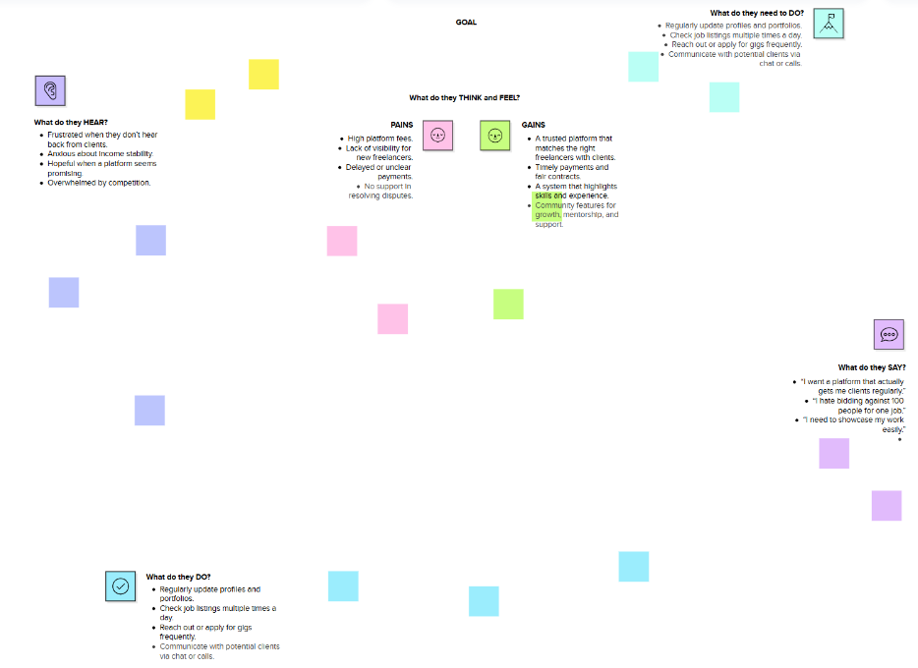

Reference: <https://www.mural.co/templates/empathy-map-canvas>